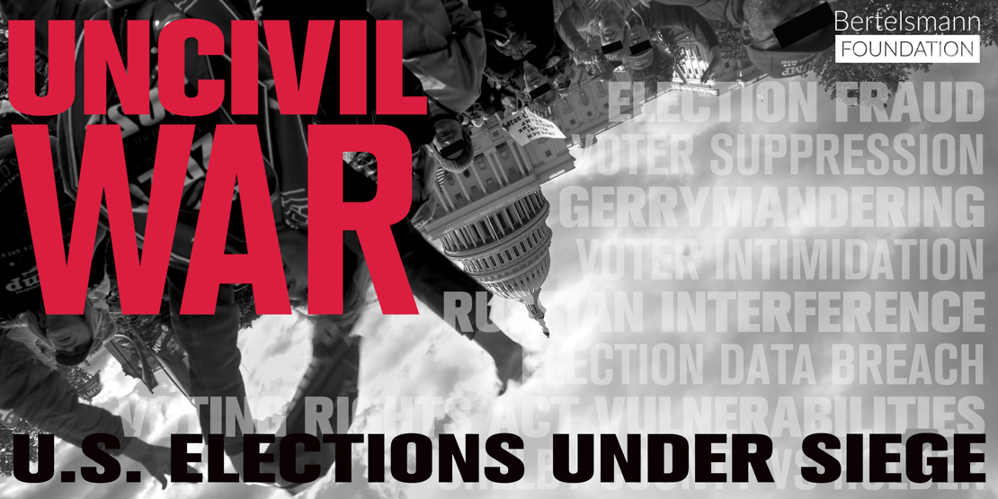

Mark your calendar!

Sunday,
November 1, 2020
4 p.m.

Uncivil War: U.S. Elections Under Siege
Via Zoom

Discussion follows

Co-sponsors:
NAACP Muncie Chapter
YWCA
Black Expo
Gerrymandering, voter suppression, disinformation... Do our votes matter anymore? Uncivil War unravels a web of threats to American elections, separates truth from fiction, and exposes a hidden war against democracy itself. Through conversations with experts, politicians, and activists fighting on both sides of the partisan divide, we examine our system of government and search for a way to renew it.

Join the League of Women Voters of Muncie-Delaware County for a screening of Uncivil War: U.S. Elections Under Siege, a
documentary film directed by Richmond, Indiana native Tom Glynn and featuring Indiana Coalition for Redistricting Reform leaders Debbie Asberry of the League of Women Voters of Indiana and Julia Vaughn of Common Cause Indiana.
REGISTER here:
https://us02web.zoom.us/meeting/register/tZMldeCrqT0rE9CtvQ7-WELlej-mQ0QLWFG4
After registering, you will receive a confirmation email containing information about joining the meeting.

